

PLANNING PROPOSAL

Amendments to Pittwater Local Environmental Plan 2014

Rezoning of Avalon Beach Bowling Club, 5 Bowling Green Lane Avalon Beach

January 2021

Contents
Part 1 – Objectives or Intended Outcomes 3
Part 2 – Explanation of Provisions 4
Part 3 – Justification 6
Section A – Need for the Planning Proposal 6
Section B – Relationship to Strategic Planning Framework 10
Section C – Environmental, Social and Economic Impact 18
Section D – State and Commonwealth Interests 20
Part 4 – Maps 21
Part 5 – Community Consultation 23
Part 6 – Project Timeline 26

Part 1 – Objectives or Intended Outcomes

To amend the Pittwater Local Environmental Plan 2014 to rezone land at 5 Bowling Green Lane, Avalon Beach for recreational purposes.

Part 2 – Explanation of Provisions

The proposed outcome will be achieved by:

- Amending Pittwater Local Environmental Plan 2014 Land Zoning Map (Sheet LZN_016) from R2 Low Density to RE1 Public Recreation.

Map 1 - Existing Land Use Zone

Map 2 - Proposed Land Use Zone

Part 3 – Justification

Section A – Need for the Planning Proposal

- Is the Planning Proposal a result of an endorsed Local Strategic Planning Statement, strategic study or report?

Yes. The Planning Proposal is the result of endorsed former Pittwater Council Meeting recommendations relating to Green 3 (being part Lot 7 in DP 124040), 5 Bowling Green Lane Avalon Beach.as shown in Map 1.

Map 3 – Subject Land.

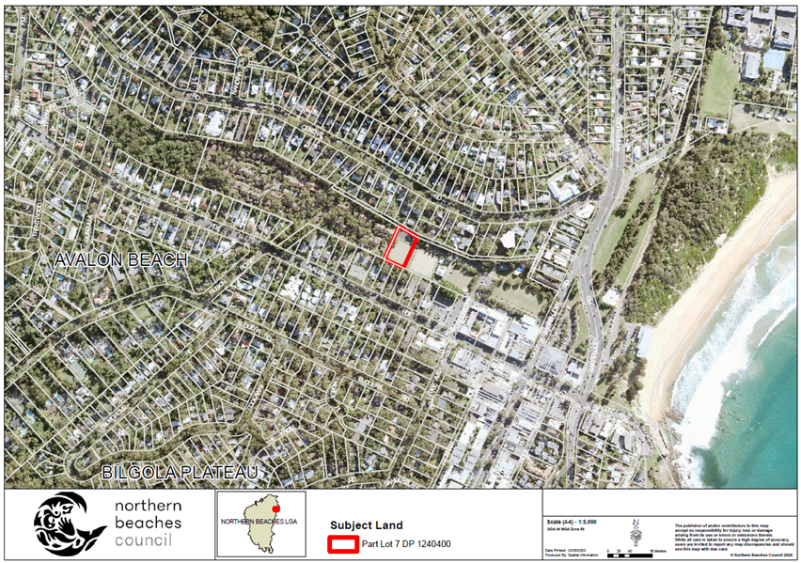

A history of the former Pittwater Council resolutions relating to the subject site is listed below in Table 1.
Table 1: Council Meetings
Council Name | Report Name | Date | Resolution
Former Pittwater Council | Avalon Bowling & Recreation Club, Bowling Green Lane, Avalon –Purchase of Green 3 by Council | 20 April 2015 | - That Council purchase Green No.3 (Lot 2 DP 517185) Bowling Green Lane, Avalon in line with Avalon Bowling & Recreation Club’s proposal comprising a total package of $765,000 broken down as follows:  - Rental for the remaining 10 years of the lease agreement for both the Club House and the middle bowling green (Green No.2) to be waived- equivalent to a total saving to Club of $165,000 (including. GST).  - $500,000. For the purchase of Green No.3 to be paid over 10 years in $ 50,000 annual payments.  - $100,000 allocated to club House repairs and upgrades in the 2015/2016 financial year.  - That this purchase be included in the 2015/2019 Delivery Program and Budget.  - That the General Manager be authorised to complete the purchase transaction and execute relevant documentation under the common seal of Council.
Former Pittwater Council | Avalon Bowling Club & Recreation Club, Bowling Green Lane, Avalon – Proposed New Consolidated Lease for Club house, Green No.2 and Green No.3 | 07 December 2015 | - That Council purchase Green No.3 (Lot 2 DP 517185) Bowling Green Lane, Avalon in line with Avalon Bowling & Recreation Club’s proposal comprising a total package of $765,000 broken down as follows:  - Rental for the remaining 10 years of the lease agreement for both the Club House and the middle bowling green (Green No.2) to be waived- equivalent to a total saving to Club of $165,000 (Inc. GST).  - $500,000. For the purchase of Green No.3 to be paid over 10 years in $ 50,000 annual payments.  - $100,000 allocated to club House repairs and upgrades in the 2015/2016 financial year.  - That this purchase be included in the 2015/2019 Delivery Program and Budget.  - That the General Manager be authorised to complete the purchase transaction and execute relevant documentation under the common seal of Council.  - That upon acquisition by Council, the subject land be classified as Community Land, the 2,390m2 be added to Council’s Open Space Strategy and Inventory, and be incorporated into the Dunbar Park Plan of Management.  - The terms and conditions be administered in accordance with Recommendation 1 above.
Former Pittwater Council | Outcome of Public Exhibition of Avalon Bowling | 15 February 2016 | - That Council note the outcomes of the public exhibition of the draft consolidated lease with Avalon Beach Bowling and Recreation Club for Green 3, Green 2 and the Clubhouse at Bowling Green Lane, Avalon.  - That as per Councils resolution dated 20 April 2015 and pursuant to the Act, Council will undertake the following soon after the completion of the contract for sale:  - Consolidate Green 3 (Lot 2 DP 517185) and Dunbar Park (Lot 6 D P 1102075).  - Reclassify Green 3 (Lot 2 DP 517185) from Operational Land to Community Land  - Re-Zone Green 3 from R2 Low Density Residential to RE1 Public Recreation.  - That simultaneously with the Consolidation of lots, Avalon Beach Bowling and Recreation Club will surrender both the Clubhouse Lease and Green 2 Lease and enter into a new consolidated lease for Green 3, Green 2 and the Clubhouse with Council as lessor and Avalon Beach Bowling and Recreation Club as lessee.  - That the General Manager be authorised to sign any documentation required to finalise the consolidated lease agreement with Avalon Beach Bowling and Recreation Club for Green 3, Green 2 and the Clubhouse, Bowling Green Lane, Avalon and to affix the common seal of Council if required.
Northern Beaches Council | Outcome of Public Exhibition of Avalon Bowling for the classification of land known as Green No.3 (Lot 2 DP 517185) at Bowling Green Lane, Avalon NSW 2107 | 13 December 2016 | That Council:  - Proceed with the classification of Green No. 3 (Lot 2 Deposited Plan 517185) at Bowling Green Lane, Avalon NSW 2107 as ‘Community Land.  - Delegate its authority to the General Manager to execute all necessary documentation to give effect to this resolution.

The proposal to change the zoning of the subject site will allow the lessee, Avalon Beach Bowling Recreation Centre, to use Green 3 for recreational uses in conjunction with the Avalon Bowling Club.

In accordance with Council resolution of the 15 February 2016, Lot 2 DP 517185 was consolidated into adjoining Council owned land comprising Dunbar Park with the new Certificate of Title, being Lot 7 in DP 124040, issued on the 7 May 2018, as shown in Map 2.

Map 2 – Plan of Subdivision

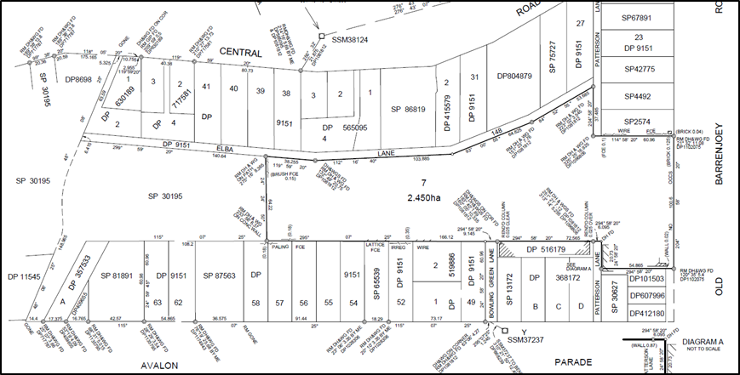

On the 26 September 2016, Council purchased the land subject to a number of conditions of sale that reinforced the actions outlined in the Council resolution, being:
- That the land comprising Green 3 be reclassified as Community Land, as soon as reasonably practicable after settlement as per the resolution of Council dated 20 April 2015 (Council Resolution).
- After completion of the Contract Council will consolidate Green 3 and Lot 6 (Consolidation).
- Green 3 will be reclassified from Operational Land to Community Land (Reclassification) and re-zoned from R2 Low Density to RE1 Public Recreation (Re-zoning) as per Council Resolution.
The outstanding actions from Council’s resolution of the 15 February 2016 and the subsequent condition of sale relate to the following:

- Re-Zone Green 3 from R2 Low Density Residential to RE1 Public Recreation.

The Planning Proposal seeks to address and finalise the Council resolution and the conditions of sale.

- Is the Planning Proposal the best means of achieving the objectives or intended outcomes, or is there a better way?

Yes, the Planning Proposal is the best means to rezone Green 3 (part of Lot 7 DP 124040, formerly being Lot 2 DP 517185) from R2 Low Density Residential to RE1 Public Recreation.

Section B – Relationship to Strategic Planning Framework

- Will the Planning Proposal give effect to the objectives and actions of the applicable regional, or district plan or strategy (including any exhibited draft plans or strategies)?

Greater Sydney Region Plan
The Planning Proposal gives effect to the following objectives of the Region Plan:
Direction | Objective | Assessment
A City supported by infrastructure. | Objective 2: Infrastructure aligns with forecast growth.  Objective 3: Infrastructure adapts to future needs. | Avalon Beach is characterised as an ageing population with static growth, the average age of residents is 45, in comparison 36 for Greater Sydney. Population projections indicate that the trend will continue with the 75 – 79 years age group experiencing the largest growth between 2016-2026.  The supply of additional open space within proximity to the village centre will service the needs and requirements of the changing demographic of the area and support the use of the site for recreational purposes in line with the current Avalon Beach Bowling and recreation Centre.
A Collaborative City | Objective 5:  Benefits of growth realized by collaboration of governments, community and business. | Council is working in collaboration with the Avalon Beach Bowling and Recreation Centre to ensure that Avalon Beach has sufficient open space to satisfy community needs now and into the future.
A City for People. | Objective 7: Communities are healthy, resilient and socially connected. | The Planning Proposal seeks to increase land zoned for the purpose of public recreation that will provide additional opportunities for the community to connect socially and physically through passive and active recreation.
A City of Great Places | Objective 12:  Great places that bring people together. | The rezoning and reclassifying of the subject site will provide the Avalon Beach Bowling and Recreation Centre the opportunity to extend the Bowling Club grounds to meet the needs of the community.

The North District Plan
The Planning Proposal gives effect to the following objectives of the North District Plan:

Direction and Planning Priority | Assessment
Livability - A city for people
Planning Priority N3  Providing services and social infrastructure to meet people’s changing needs.  Objective 6: Services and infrastructure meet communities’ changing needs. | The demographics of Avalon Beach is changing with the highest growth experienced in the 75 -79 age group. The average age is 45, in comparison to 36 for Greater Sydney, with 50% of people aged between 35-69 years.  Avalon Beach is an aging population and the planning proposal will provide additional open space zoned land to meet the demographic trend and changing needs and requirements of the community now and into the future.
Planning Priority N4  Fostering healthy, creative, culturally rich and socially connected communities.  Objective 7: Communities are healthy, resilient and socially connected. | The Planning Proposal seeks to increase land zoned for public recreation purposes in the Avalon Beach locality. The additional public open space will provide additional opportunities for the community to connect socially and physically through passive and active recreation activities associated with the Avalon Beach Bowling club and surrounding Dunbar Park area.
Planning Priority N6  Creating and renewing great places and local centers, and respecting the District’s heritage.  Objective 12: Great places that bring people together. | Dunbar Park is located within the Avalon Beach village and holds significant value to the local community. Dunbar Park consists of a diverse range of facilities and infrastructure catering to the social and recreational needs of the community.  The Planning Proposal will facilitate and enable the Avalon Beach Bowling and Recreation Centre to expand their current activities and foster the development of a social and recreational hub that will bring the community together for range of social and recreation purposes.
Sustainability – Valuing green spaces and landscapes
Planning Priority N20  Delivering high quality open space  Objective 31 Public space is accessible, protected and enhanced. | The North District Plan highlights the importance of open space as a form of green infrastructure that not only enhances the character of the District, but also supports active lifestyles and provides opportunities to unite and bring communities together.  The District Plan recognises that there is limited opportunity to increase the quantity of open space.  The Planning Proposal addresses this issue and seeks to provide additional open space zoned land by rezoning R2 Residential Low Density land to RE1 Public Open Space.
Planning Priority N22  Adapting to the impacts of urban and natural hazards and climate change  Objective 37 Exposure to natural and urban hazards is reduced | The site is subject to high and medium flood hazards in the 1% AEP flood event. The District North Plan advocates the need to avoid or reduce exposure to natural hazards were possible. The site is zoned for residential purposes that will permit additional residential development to be exposed to flooding hazards. The Planning Proposal seeks to remove the residential land zoning and replace it with a public open space zone which is compatible with the flood affectation of the site.

- Does the proposal have strategic merit?

Yes. The Planning Proposal gives effect to endorsed former Pittwater Council Meeting recommendations relating to 5 Bowling Green Lane, Avalon Beach. Furthermore it will give effect to the relevant directions and objectives of the Greater Sydney Region Plan, specifically objectives 2,3,5,7and 12, and Planning Priority N3, N4, N6 and N20 of the Sydney North District Plan.

- Does the proposal have site-specific merit?

Yes. The Planning Proposal has site-specific merit. While the site is currently zoned R2 Low Density Residential and adjoins residential zoned land to the north, south and west, it has historically been used for open space and recreation purposes as part of the Avalon Bowling Club and adjoins Dunbar Park to the east. Furthermore, in accordance with the Council resolutions relating to the purchase of the subject site the land has been consolidated into Dunbar Park and will be leased to Avalon Beach Bowling and Recreation Centre for recreational uses.
- Will the Planning Proposal give effect to a Council’s endorsed Local Strategic Planning Statement, or another endorsed local strategy or strategic plan?

Yes. The Planning Proposal gives effect to the following priorities of the Northern Beaches Local Strategic Planning Statement

Priority | Principles | Planning Proposal
Priority 6  High quality open space for recreation | - Improve the provision, diversity and quality of open space for recreation.  - Ensure open space responds to demand and meets diverse community needs.  - Encourage collaboration and partnerships to promote use. | Priority 6 recognises that open space forms a central part of the Northern Beaches lifestyle and supports leisure for fun, relaxation or fitness.  The Planning Proposal will retain the current use of the site, as open space, and rezone the land to RE 1 Public Recreation to reflect the use and ensure it remains open space into the future.
Priority 11  Community facilities and services that meet changing community needs. | - Enhance the effectiveness of existing facilities  - Encourage partnerships for shared and joint use of government and privately owned facilities for community uses | The Priority seeks to provide a range of community facilities and services that allow people to connect, create and learn.  The Planning Proposal seeks to rezone the site to RE1 Public Recreation to support the continuation of the site for open space and recreation uses undertaken by Avalon Beach Bowling Recreation Centre. The proposal will also allow for the expansion of the bowling club grounds to meet the increasing demands of an ageing population within the community.

- Is the Planning Proposal consistent with applicable State Environmental Planning Policies?

Yes the Planning Proposal is considered consistent with applicable State Environmental Planning Policies (as shown in Table 2), namely:

State Environmental Planning Policy (Koala Habitat Protection) 2019
The SEPP and associated guidelines are to be applied in two ways, being:

- By councils preparing Koala Plans of Management which forms part 2 of the Guideline,

- By landholders and councils when preparing and assessing a development application under part 3 of the Guideline.

The Planning Proposal is consistent with the requirements of the SEPP.

- State Environmental Planning Policy No. 55 – Remediation of Land

The site is currently zoned R2 Low Density Residential and caters for residential land uses. The Planning Proposal seeks to rezone the site to RE1 Public Recreation. Given the current zoning and history of the site, the risk of contamination possibilities is considered low.

Table 2: Compliance with State Environmental Planning Policies (SEPPs)

SEPPs (as at November 2020) |  | Applicable | Consistent
19 | Bushland in Urban Areas | Yes | Yes
21 | Caravan Parks | Yes | Yes
33 | Hazardous and Offensive Development | Yes | Yes
36 | Manufactured Home Estates | Yes | Yes
47 | Moore Park Showground | No | N/A
50 | Canal Estate Development | Yes | Yes
55 | Remediation of Land | Yes | Yes
64 | Advertising and Signage | Yes | Yes
65 | Design Quality of Residential Apartment Development | No | N/A
70 | Affordable Housing (Revised Schemes) | Yes | Yes
 | (Aboriginal Land) 2019 | No | N/A
 | (Activation Precincts) 2020 | No | N/A
 | (Affordable Rental Housing) 2009 | Yes | Yes
 | (Building Sustainability Index: BASIX) 2004 | YES | Yes
 | (Coastal Management) 2018 | No | N/A
 | (Concurrences and Consents) 2018 | No | N/A
 | (Education Establishments and Child Care Facilities) 2017 | Yes | Yes
 | (Exempt and Complying Development Codes) 2008 | Yes | Yes
 | (Gosford City Centre) 2018 | No | N/A
 | (Housing for Seniors or People with a Disability) 2004 | Yes | Yes
 | (Infrastructure) 2007 | Yes | Yes
 | (Koala Habitat Protection) 2019 | Yes | Yes
 | (Kosciuszko National Park – Alpine Resorts) 2007 | No | N/A
 | (Kurnell Peninsula) 1989 | No | N/A
 | (Mining, Petroleum Production and Extractive Industries) 2007 | No | N/A
 | (Major Infrastructure Corridors) 2020 | No | N/A
 | (Penrith Lakes Scheme) 1989 | No | N/A
 | (Primary Production and Rural Development) 2019 | No | N/A
 | (State and Regional Development) 2011 | No | N/A
 | (State Significant Precincts) 2005 | No | N/A
 | (Sydney Drinking Water Catchment) 2011 | No | N/A
 | (Sydney Region Growth Centres) 2006 | No | N/A
 | (Three Ports) 2013 | No | N/A
 | (Urban Renewal) 2010 | No | N/A
 | (Vegetation in Non-Rural Areas) 2017 | Yes | Yes
 | (Western Sydney Aerotropolis) 2020 | No | N/A
 | (Western Sydney Employment Area) 2009 | No | N/A
 | (Western Sydney Parklands) 2009 | No | N/A
Sydney Regional Environmental Plans (Deemed SEPPs):
8 | (Central Coast Plateau Areas) | No | N/A
9 | Extractive Industry (No 2 -1995) | No | N/A
16 | Walsh Bay | No | N/A
20 | Hawkesbury – Nepean River (No 2 – 1997) | No | N/A
24 | Homebush Bay Area | No | N/A
26 | City West | No | N/A
30 | St Marys | No | N/A
33 | Cooks Cove | No | N/A
 | (Sydney Harbour Catchment) 2005 | No | N/A

- Is the Planning Proposal consistent with applicable Ministerial Directions (s9.1 directions)?

The Planning Proposal is consistent with applicable Ministerial Directions (as shown in Table 3) including:

S9.1 Direction | Requirement | Comment
3.1 Residential Zones  Objectives  (1) The objectives of this direction are: (a) to encourage a variety and choice of housing types to provide for existing and future housing needs,  (b) to make efficient use of existing infrastructure and services and ensure that new housing has appropriate access to infrastructure and services, and  (c) to minimise the impact of residential development on the environment and resource lands. | A planning proposal must include provisions that encourage the provision of housing that will:  (a) broaden the choice of building types and locations available in the housing market, and  (b) make more efficient use of existing infrastructure and services, and  (c) reduce the consumption of land for housing and associated urban development on the urban fringe, and  (d) be of good design.  (5) A planning proposal must, in relation to land to which this direction applies:  (a) contain a requirement that residential development is not permitted until land is adequately serviced (or arrangements satisfactory to the council, or other appropriate authority, have been made to service it), and  (b) not contain provisions which will reduce the permissible residential density of land. | While the site is zoned for residential purposes, it has historically been used for open space and recreational purposes.  Council now seeks to amend the existing zoning from R2 Low Density to RE1 Public Recreation to reflect the current and long-term use of the land as open space and recreation.
4.3 Flood Prone Land  Objectives  (1) The objectives of this direction are: (a) to ensure that development of flood prone land is consistent with the NSW Government’s Flood Prone Land Policy and the principles of the Floodplain Development Manual 2005, and (b) to ensure that the provisions of an LEP on flood prone land is commensurate with flood hazard and includes consideration of the potential flood impacts both on and off the subject land. | This direction applies when a relevant planning authority prepares a planning proposal that creates, removes or alters a zone or a provision that affects flood prone land. | The site is flood affected in the 1% AEP flood event.  Amending the zoning of the site from residential to public recreation will reduce potential flooding impacts on adjoining residential properties.
- Approval and Referral Requirements  The objective of this direction is to ensure that LEP provisions encourage the efficient and appropriate assessment of development. | This direction seeks to minimise provisions that require the concurrence, consultation or referral of  development applications to a Minister or public authority. | The Planning Proposal does not seek to introduce approval or referral requirements and is consistent with the Direction.
6.2 Reserving Land for Public Purposes.  a) To facilitate the provision of public services and facilities by reserving land for public purposes. | A planning proposal must not create, alter or reduce existing zonings or reservations of land for public purposes without the approval of the relevant public authority and the Director-General of the Department of Planning. | Council purchased the site on 26 September 2016 from Avalon Beach Bowling and Recreation Centre.  Council now seeks to amend the existing zoning from R2 Low Density to RE1 Public Recreation to reflect the current and long-term use of the land as open space and recreation.
7.1 Implementation of ‘A plan for growing Sydney.’ | The objective of this direction is to give legal effect to the vision, transport and land use strategy, policies, outcomes and actions contained in ’A plan for growing Sydney’. | This Planning Proposal is consistent with the directions and objectives of the Greater Sydney Regional Plan – A Metropolis of Three Cities, as referred to under 3.1.

Table 3: Compliance with Ministerial Directions

Directions (as at November 2020) |  | Applicable | Consistent
1 | Employment and Resources
1.1 | Business and Industrial Zones | No | N/A
1.2 | Rural Zones | No | N/A
1.3 | Mining, Petroleum Production and Extractive Industries | No | N/A
1.4 | Oyster Aquaculture | No | N/A
1.5 | Rural Lands | No | N/A
2 | Environment and Heritage
2.1 | Environment Protection Zones | No | N/A
2.2 | Coastal Protection | No | N/A
2.3 | Heritage Conservation | No | N/A
2.4 | Recreation Vehicle Areas | No | N/A
2.5 | Application of E2 and E3 Zones and Environmental Overlays in Far North Coast LEP’s | No | N/A
3 | Housing, Infrastructure and Urban Development
3.1 | Residential Zones | Yes | Yes
3.2 | Caravan Parks and Manufactured Home Estates | No | N/A
3.3 | Home Occupations | No | N/A
3.4 | Integrating Land Use and Transport | No | N/A
3.5 | Development Near Licensed Aerodromes | No | N/A
3.6 | Shooting Ranges | No | N/A
3.7 | Reduction in non-hosted short term rental accommodation period | No | N/A
4 | Hazard and Risk
4.1 | Acid Sulfate Soils | No | N/A
4.2 | Mine Subsidence and Unstable Land | No | N/A
4.3 | Flood Prone Land | Yes | Yes
4.4 | Planning for Bushfire Protection | No | N/A
5 | Regional Planning
5.1 | Implementation of Regional Strategies | No | N/A
5.2 | Sydney Drinking Water Catchments | No | N/A
5.3 | Farmland of State and Regional Significance on the NSW Far North Coast | No | N/A
5.4 | Commercial and Retail Development along the Pacific Highway, North Coast | No | N/A
5.5 | Development in the vicinity of Ellalong, Paxton and Millfield (Cessnock LGA) (Revoked 18 June 2010) | No | N/A
5.6 | Sydney to Canberra Corridor (Revoked 10 July 2008 See amended Direction 5.1) | No | N/A
5.7 | Central Coast (Revoked 10 July 2008. See amended Direction 5.1) | No | N/A
5.8 | Second Sydney Airport: Badgerys Creek (Revoked 20 August 2018) | No | N/A
5.9 | North West Rail Link Corridor Strategy | No | N/A
5.10 | Implementation of Regional Plans | No | N/A
5.11 | Development of Aboriginal Land Council land | No | N/A
6 | Local Plan Making
6.1 | Approval and Referral Requirements | Yes | Yes
6.2 | Reserving Land for Public Purposes | Yes | Yes
6.3 | Site Specific Provisions | No | N/A
7 | Metropolitan Planning
7.1 | Implementation of A Plan for Growing Sydney | Yes | Yes
7.2 | Implementation of Greater Macarthur Land Release Investigation | No | N/A
7.3 | Parramatta Road Corridor Urban Transformation Strategy | No | N/A
7.4 | Implementation of North West Priority Growth Area Land Use and Infrastructure Implementation Plan | No | N/A
7.5 | Implementation of Greater Parramatta Priority Growth Area Interim Land Use and Infrastructure Implementation Plan | No | N/A
7.6 | Implementation of Wilton Priority Growth Area Interim Land Use and Infrastructure Implementation Plan | No | N/A
7.7 | Implementation of Glenfield to Macarthur Urban Renewal Corridor | No | N/A
7.8 | Implementation of Western Sydney Aerotropolis Interim Land Use and Infrastructure Implementation Plan | No | N/A
7.9 | Implementation of Bayside West Precincts 2036 Plan | No | N/A
7.10 | Implementation of Planning Principles for the Cooks Cove Precinct | No | N/A
7.11 | Implementation of St Leonards and Crows Nest 2036 Plan | No | N/A
7.12 | Implementation of Greater Macarthur 2040 | No | N/A

Section C – Environmental, Social and Economic Impact

- Is there any likelihood that critical habitat or threatened species, populations or ecological communities, or their habitats, will be adversely affected as a result of the proposal?

No. There are no threatened species, critical habitat or ecological communities mapped on the site or within close proximity. The site is developed and used as a bowling green and forms part of Avalon Bowling Club. The Planning Proposal is to rezone the land so it is consistent with the remainder of Lot 7 DP 124040.

- Are there any other likely environmental effects as a result of the Planning Proposal and how are they proposed to be managed?

No. The Planning Proposal will not have any environmental effects. The proposal seeks to rezone the site to ensure it is consistent with the historical and current use of the site and remainder of Lot 7 in DP 124040.

- Has the Planning Proposal adequately addressed any social and economic effects?

The Planning Proposal will not have any negative social or economic effects on the Avalon Beach locality. The zoning of the site is inconsistent with the remainder of Lot 7 in DP124040, which forms Dunbar Park. The proposal seeks to address the inconsistency and rezone the site to public recreation, which is consistent with its current and future use and is in line with community expectation.

Section D – State and Commonwealth Interests

- Is there adequate public infrastructure for the planning proposal?

Yes. The site is used for recreational purposes and has adequate public infrastructure to serve the planning proposal, including the provision of a public car park that is adjacent to the Avalon Bowling Club and Dunbar Park.

- What are the views of State and Commonwealth public authorities consulted in accordance with the Gateway determination?

The Planning Proposal is being prepared in accordance with consultation guidelines and provisions prepared by the Department of Planning, Industry and Environment and all statutory consultation will occur in accordance with the requirements of any future Gateway Determination, including any State or Commonwealth authorities.

Part 4 – Maps

Map 3 – Site Identification Map

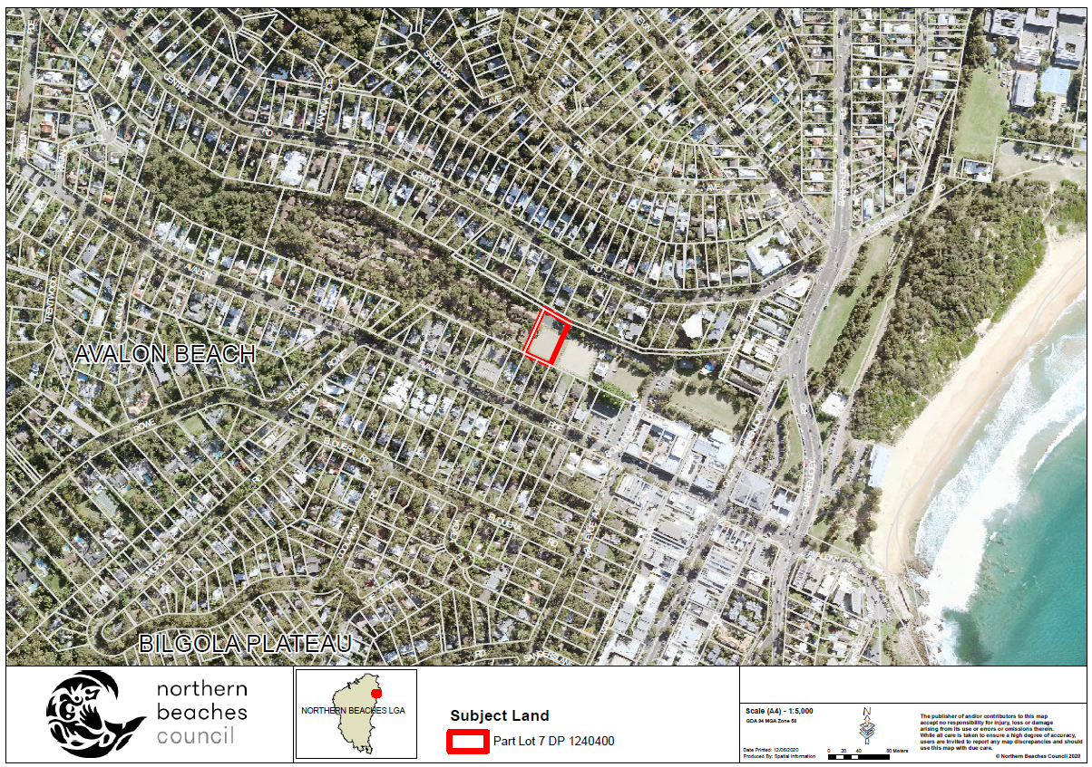

Map 4 – Land Use Zoning Map

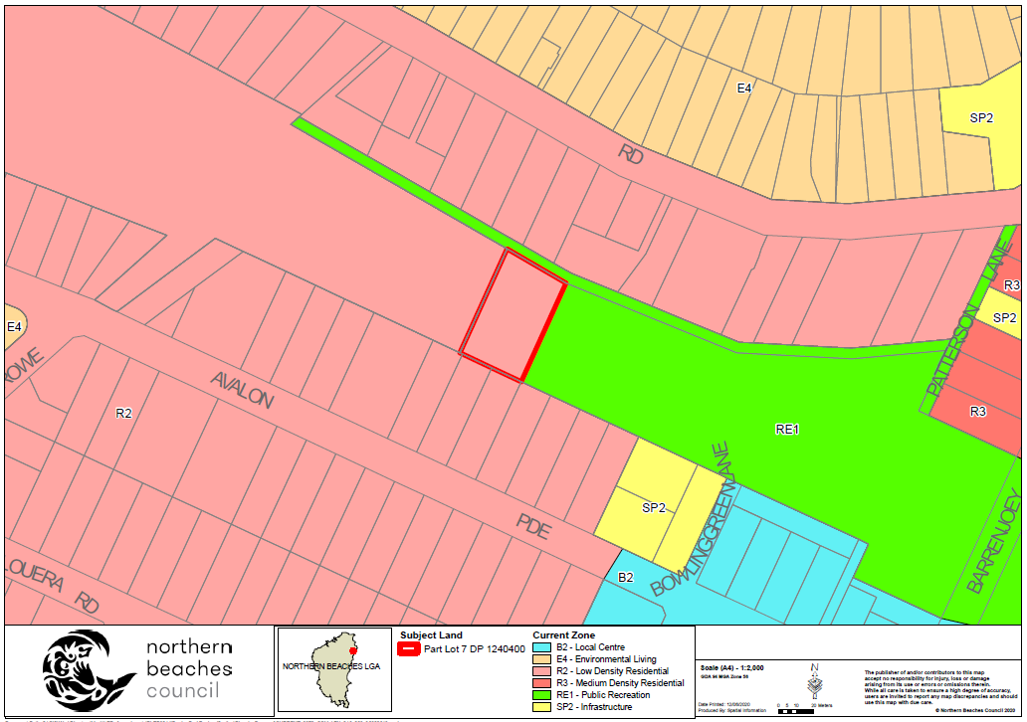

Map 5 – Proposed Land Use Zoning Map

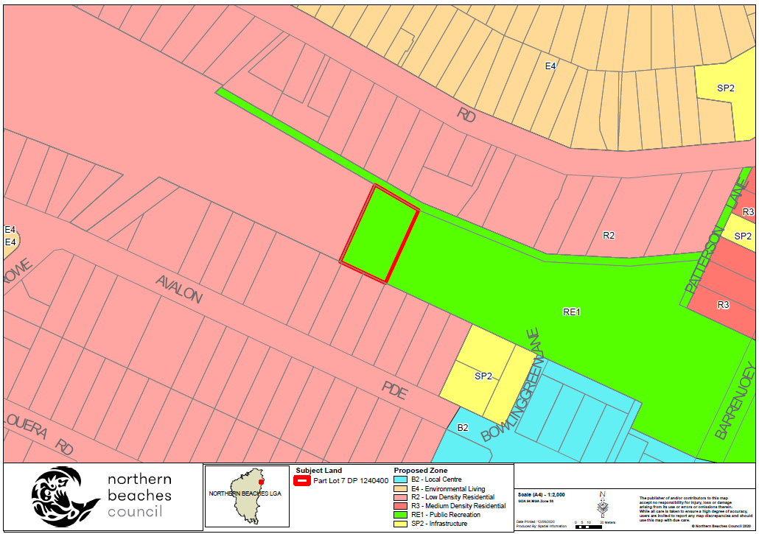

Part 5 – Community Consultation

The Planning Proposal was placed on non-statutory public exhibition in accordance with the Northern Beaches Community Participation Plan for two weeks, from 6 November to 20 November 2020. Notification included:

- Letters to land owners and occupiers adjoining the subject site
- Electronic copies of the exhibition material on Council’s website
- Emails to registered community members who have listed their interest on Council’s Community Engagement Register

During the non -statutory exhibition, three submissions were received in support of the Planning Proposal.

Part 6 – Project Timeline

Task | Anticipated timeframe
Anticipated commencement date (Gateway determination) | June 2021
Anticipated timeframe for the completion of required technical information | July 2021
Timeframe for government agency consultation (pre and post exhibition as required by Gateway determination) | July 2021
Commencement and completion dates for public exhibition period | July- August 2021
Timeframe for consideration of submissions | August - September 2021
Timeframe for the consideration of a proposal post exhibition | September 2021
Date of submission to the Department to finalise the LEP | October 2021
Anticipated date the local plan-making authority will make the plan (if authorised) | November 2021
Anticipated date the local plan-making authority will forward to the PCO for publication | December 2021

